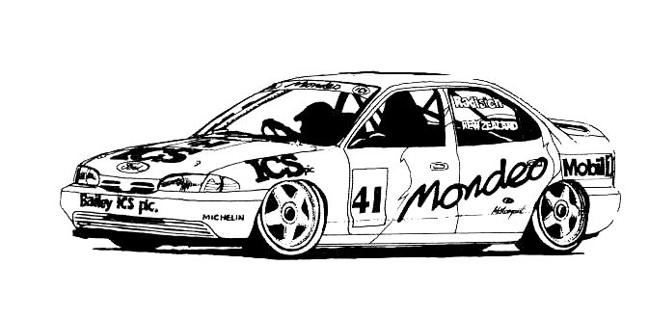
HENDERSON MINIATURE MOTOR RACING CLUB Inc.

2007

12 Hour Endurance Race

The 2007 12 Hour Endurance Race has come and gone for another year, it was the closest enduro that I have competed in, there was only 37 laps difference between first and second place at the finish of 12 hours of hard racing and slick pit work, at any time there was never any more than 136 laps between them.

The four teams where made up of club members with two visitors from down country Alan Robinson from Rotorua and Neal from Cambridge.

The Champs Team had last years winners Kieran & Rob Dale and this year had three juniors, Brad Emmott, Sean Page and Joshua Wilson join them with high hopes of another win.

The Cool Runnings Team of Rob Harrowfield, Barry Milicich, Clive Beveridge and Neal, this team after practice and qualifying looked to be the team to beat the car ran smooth and fast and with four fast drivers looked to be the ones to take top honours.

The Last Minute Team of Dave Mullins, Ray Jackson, Dave West and his two sons Kevin and Chris, Rick Mather, Jan Pak and Paul Young, this team was put together at the last minute, the team name says it all, the car was built by Dave Mullins with the body by Paul Young.

The Young Guns, this team was put together by our President Ray Smith for the remainder of the juniors, Mitchell Stevenson, Campbell Palmer, Tom Walden, Liam Palmer and Alan Robinson giving the team some experience, Ray’s attention to detail giving then a big advantage in taking out the Concourse competition.

The race got under way at 9.00am sharp with the Champs Team racing into a 36 lap lead over the Last Minute Team at the end of the first hour, then in the second hour the Champs experienced the first of there many problems finishing only 10 laps ahead at the two hour mark, Kieran came to the rescue and raced the next hour on his own to give them a 52 lap lead over the Cool Runnings Team before he left to go to a wedding.

Then it was all down hill from then on for the Champs losing ground to the fast smooth Cool Runnings Team and at the end of the 9th hour was some 135 laps down and only 270 laps up on the consistent 3rd place Last Minute Team.

The Champs where now on there third motor (sealed Parma super 16D motor) sixth spur gear and now running a brass one in desperate hope of getting to the end of the race. But as endurance racing goes you don’t know what is just around the corner, it was Cool Runnings Team turn to have problems having to change a motor, not only did the Champs make up the 135 laps but putting another 13 laps on them, going into the eleventh hour with only 13 laps separating the two top teams.

Just before 7.00pm the Champs number one driver called back into check on progress, seeing we where only just ahead, pick up his controller and showed just how fast he can be even with a car that was nearing its use by date and lapping some .4 to .5 of a second a lap fast than any other car on the track and that was with a excess blood alcohol level.

The start of the last hour the pressure was on between first and second place with only 38 laps separating them, the Champs decided not to change tires for the last hour just it case the handling of the car change to much as the three junior members of the team where given the task of bring the car home, the decision paid off with the three young lads showing there skills to bring the car home 37 laps ahead with chasses on the deck.

This would have had to be the hardest fort Enduro I have been involved in, congratulations must go to the winning team especially the three young lads, I hope all the racers had a great day and will be back next year to take up the challenge of endurance racing.

